**National College of Computer Studies**

**Paknajol, Kathmandu**

**Report on**

**“Travel Agency Management System”**

**Submitted By: -**

**Suveksha Shrestha**

**Sudina Manandhar**

**Rushma Bajracharya**

**Rohit Bajracharya**

**BIM 4th Semester**

**Acknowledgment**

This report entitled and quoted “Travellove” is prepared in partial fulfillment of the requirement of the Laravel Project for the Bachelor's level. It is the result of the cooperation and support of our teachers. We would like to express our deepest appreciation to our honorable supervisor Mr. Sarbeshwor Kapali, whose help and stimulating suggestions and encouragement helped us complete this project.

We would also like to express our sincere thanks to our teacher Mr. Sudil Maharjan and the Head of the Computer Science Department Mr. Dinesh Khadka for providing suggestions and guidance in preparing this report. Your precious time has certainly helped us give meaning to our report.We appreciate the guidance given by other supervisors and lecturers and our peers who helped clear our understanding and created a concern of completing the project report carefully and with good knowledge and quality.

The contributors of many authors and publishers in the computer industry that contributed case materials, ideas, and content used in the text are also thankfully acknowledged.

**Abstract**

This report was prepared for the project “Travellove”. The system’s main objective is to make the whole travel booking process much easier and convenient for customers as well as employees. As everything can be done online, there is less chance of mistakes, and more efficient. Also automating the system will reduce the time for storing any data in the system.

**Table of content**

**Travellove** **1**

**Introduction:** **1**

**Features:** **1**

**Objectives:** **1**

**Modules:** **2**

**Limitations:** **2**

**Future Prospects:** **2**

**Er diagram:** **3**

**Screenshots:** **4**

**User side:** **4**

**Admin side:** **6**

**Conclusion:** **7**

**References:** **8**

# **Travellove**

## **Introduction:**

“Travellove” is a Web application designed for Inbound and Outbound Tours travelers. It is a PHP Laravel-based project where users are allowed to book their favorite travel packages online in their browser where they want to travel. As a result, this makes the whole travel booking process much easier and more convenient for customers as well as employees. It simplifies the process of online booking, package customization, itinerary creation, and back-office management. As everything can be done online, there is less chance of mistakes, and more efficient.

Travellove is a travel website that never disappoints its users. Our focus is to bring utmost joy and truly a memorable experience for all our customers, which not only brings back the most enjoyable experience but also gives them a reason to share their experiences with others.

## **Features:**

* Responsive web page.
* Admin panel with add, delete, and edit operations for the admin user.
* Sign in and sign out feature for admin panel security.
* Data validation for eliminating duplicate entries and maintaining the accuracy and quality of data.

## **Objectives:**

* To minimize the possibilities of mistakes due to human error i.e. maintains accuracy and consistency of data.
* To automate the booking system with efficiency and accuracy.
* To maintain timeliness.

## **Modules:**

* **Admin:**
  + Admin can view, add, delete and update tickets and package inquiries.
  + Admin can sign in and sign out. The system will check the admin user name and password for authentication. After the verification for authorization, the admin can be able to precede the process. All works are done under his control.
* **User**
  + Ticket booking
  + Package booking
  + Users can make an inquiry.

## **Limitations:**

* Ticket validation hasn’t been done.
* Success message after ticket booking doesn't show up.
* The Admin side is not fully responsive.

## **Future Prospects:**

* User booking history.
* Package creation and deletion by admin.
* Delegate admin roles and responsibilities.

## **ER- diagram:**

## 

## **Screenshots:**

### **User side:**

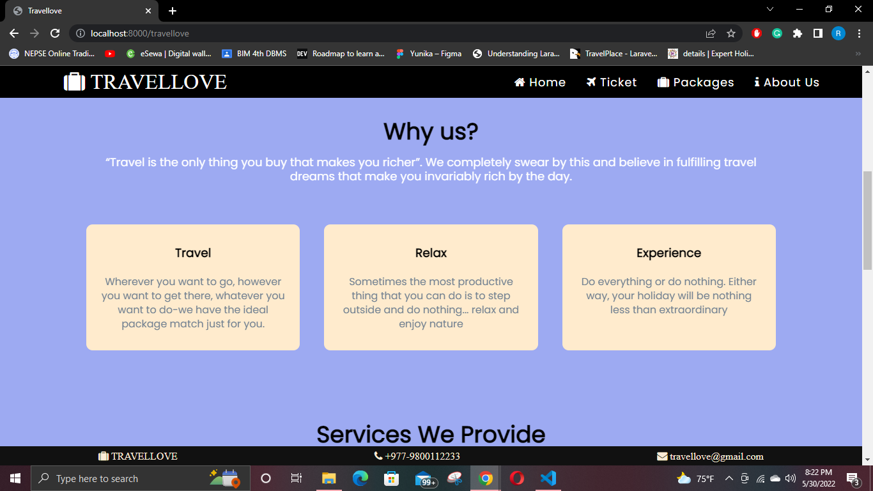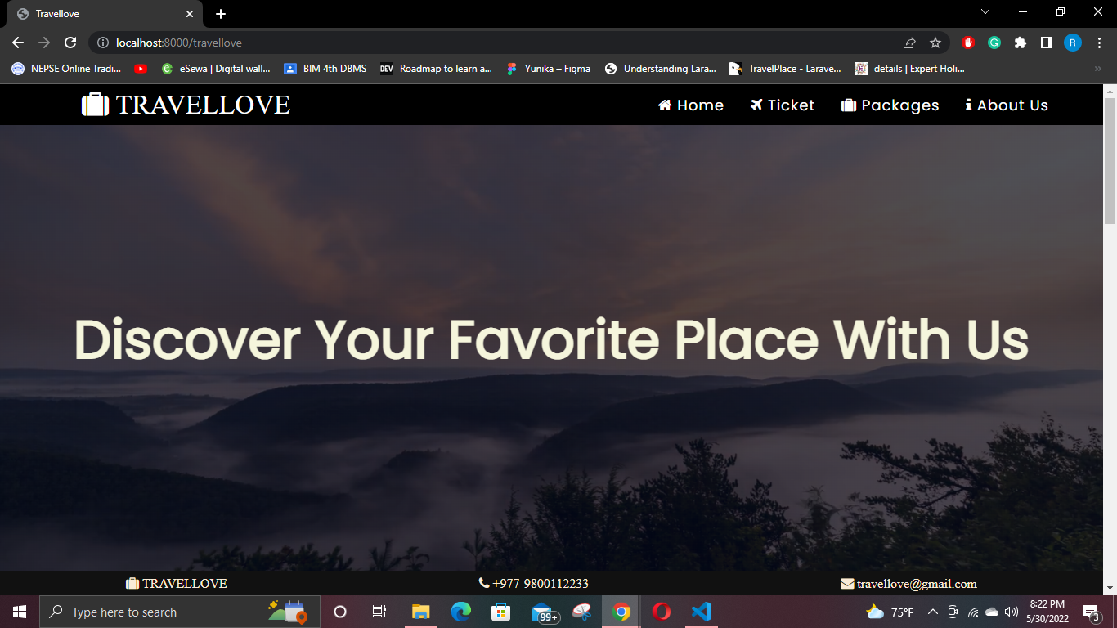

#### 

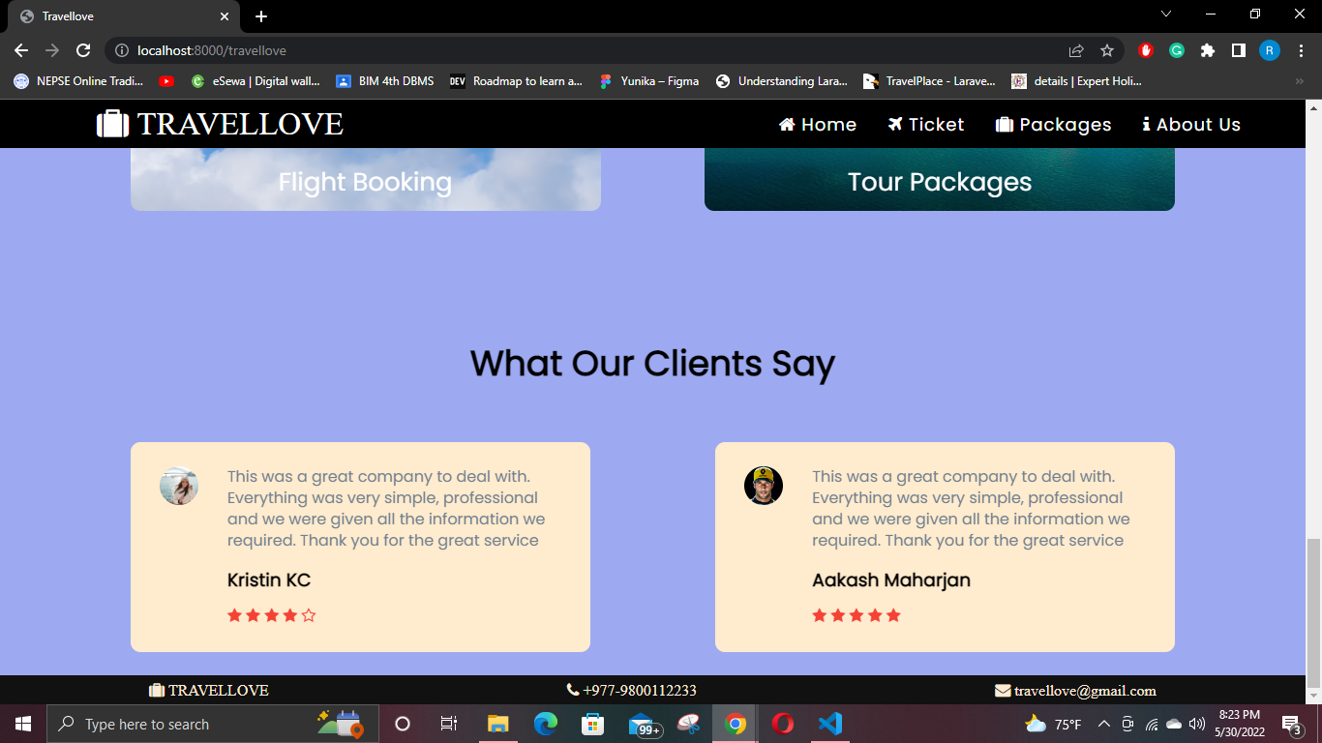

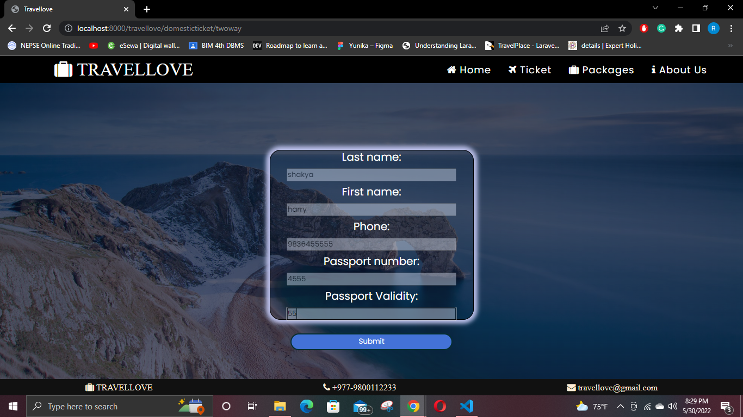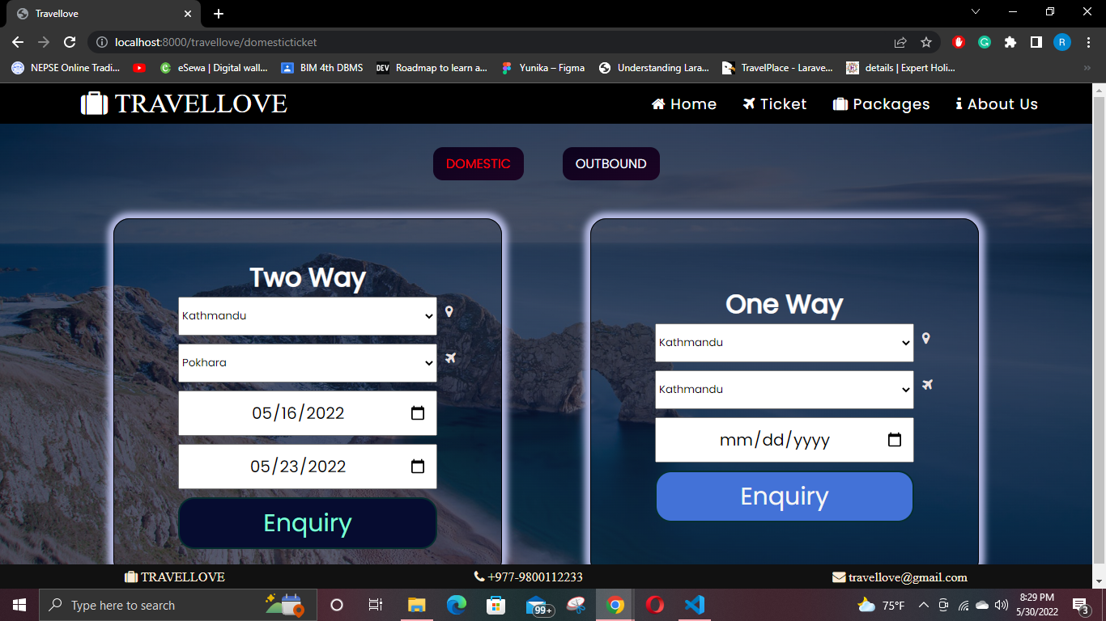

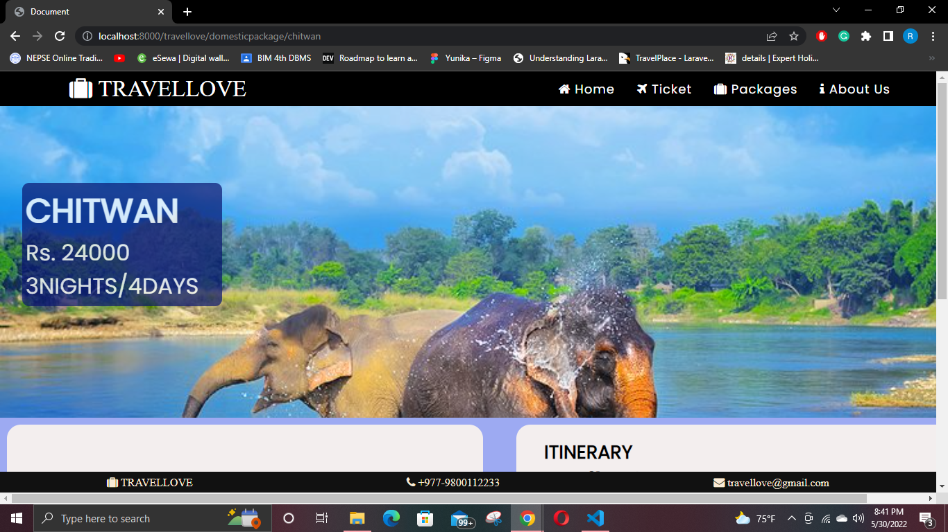

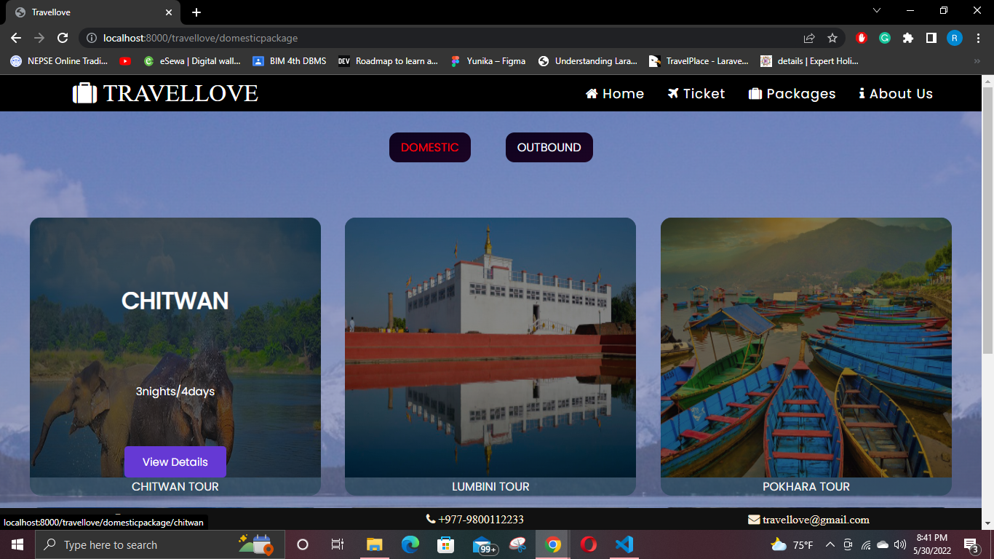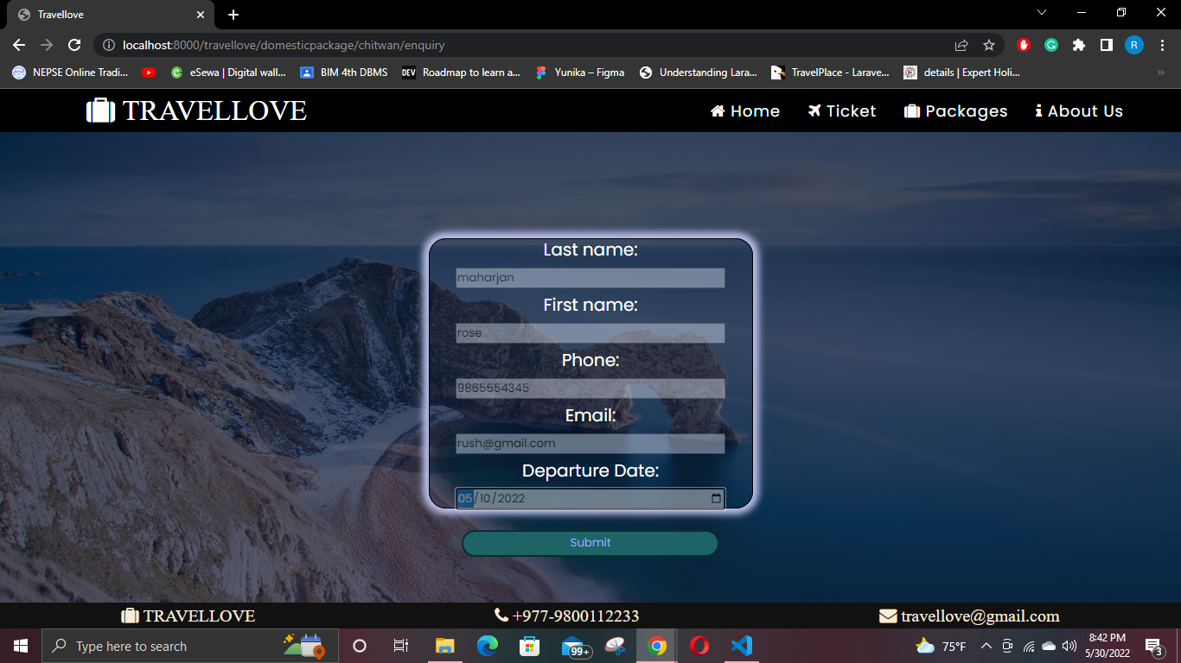

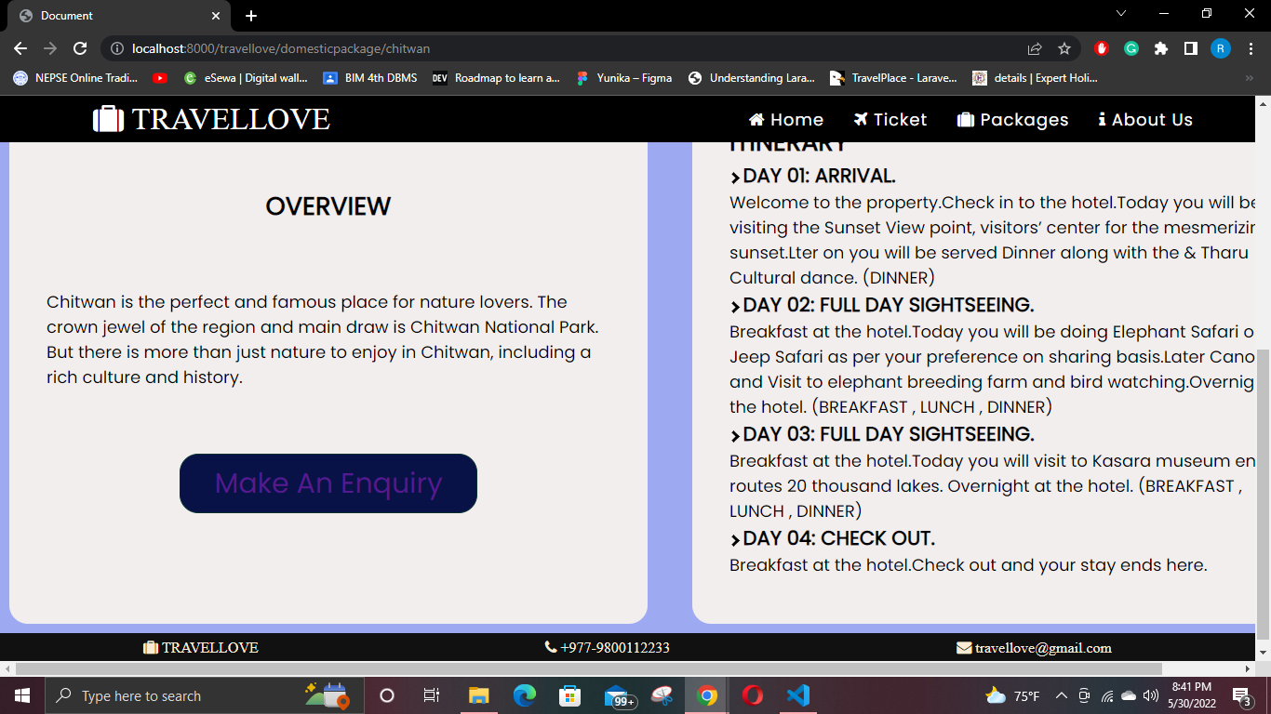

A

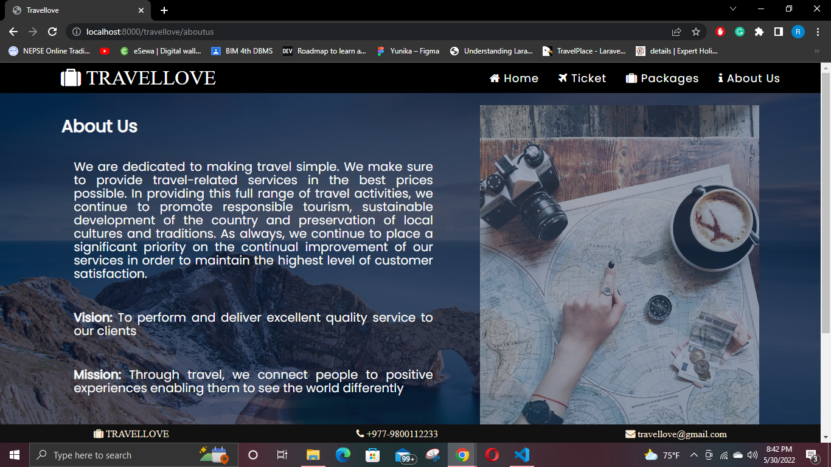

### **Admin side:**

### 

### 

### 

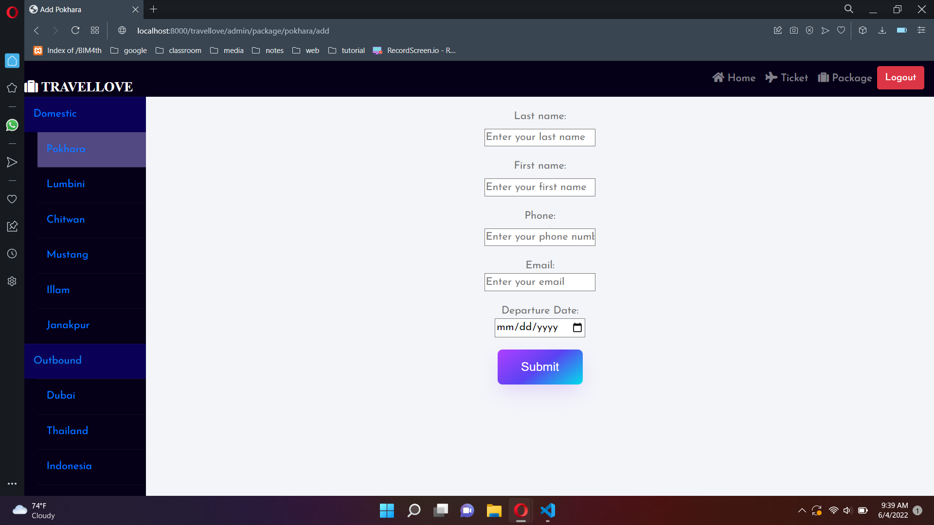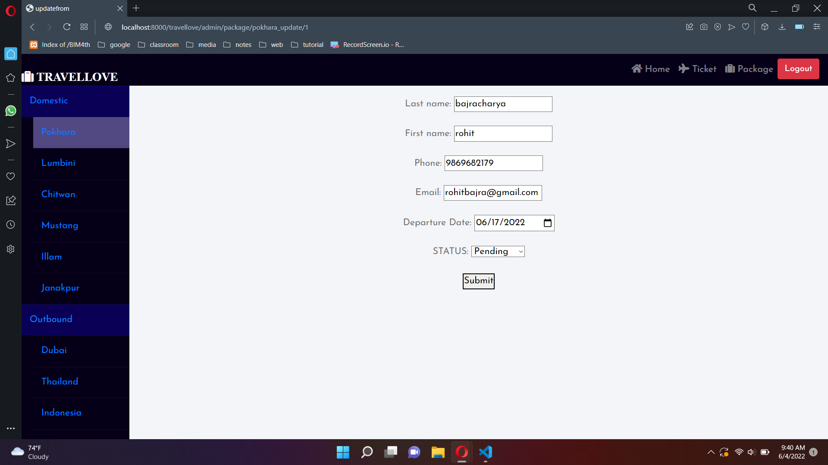

# **Conclusion:**

Tourism is regarded as one of the largest global industries in the world which are rapidly growing at a high rate like other industries. The role of technology has become a crucial aspect behind the success of every industry. It cannot be denied that technology has made the lives of people much faster and smarter. Therefore, it brings up the trend that causes the tourism industry to make use of an online management system for their business.

This website allows users to book their favorite travel packages and tickets online on their browsers easily. It simplifies the process of online ticket booking, package customization, itinerary, and back-office management. This makes the whole travel booking process much more easier and convenient. The design is pretty simple and the user won’t find it difficult to understand, use and navigate.

# References:

1. <https://www.acetravels.com>
2. <http://experts.holiday>
3. <https://www.pexels.com/search/HD/>
4. https://pixabay.com/images/search/hd/